Report
Team ID | MCA
Project Name | Smartphone Addiction & Digital Well-Being Analysis
Maximum Marks | 5 Marks
This report explains the main findings from the Smartphone Addiction and Digital Well-Being Power BI dashboards. The report uses charts, cards, filters, and other visuals to study smartphone usage, screen time, stress, age, sleep, and addiction levels.
Power BI Report 1: Smartphone Addiction & Digital Well-Being Insights
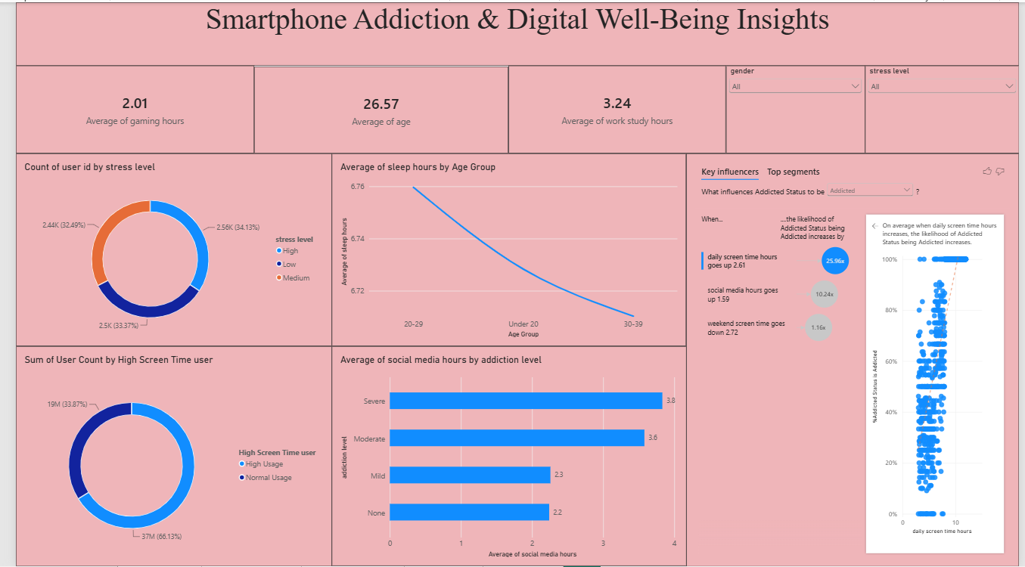
1. Average User Details:
The average age of the users is 26.57 years. The average gaming time is 2.01 hours, and the average work or study time is 3.24 hours.
2. Stress-Level Distribution:
The users are divided into high, low, and medium stress groups. High stress is about 34.13%, low stress is about 33.37%, and medium stress is about 32.49%.
3. Age-Group Analysis:
The 20–29 age group has the highest number of users. It is followed by the 30–39 age group and the under-20 age group.
4. Screen Time and Addiction:
The Key Influencers visual shows that higher daily screen time is strongly connected with a higher chance of being classified as addicted. Social media usage also has an important connection.
5. Sleep Hours:
Average sleep hours are almost similar across the age groups. The 20–29 group has around 6.76 hours of sleep, while the 30–39 group has around 6.71 hours.
Power BI Report 2: Digital Addiction & Screen Time Behavior Analysis
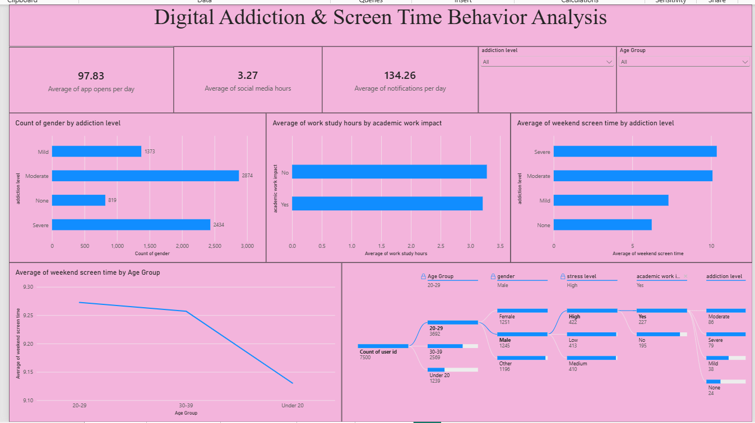
6. Daily App Usage:
Users open applications an average of 97.83 times per day. The average social media usage is 3.27 hours, and the average number of notifications is 134.26 per day.
7. Addiction-Level Distribution:
The moderate addiction group has the highest number of users, followed by the severe, mild, and no-addiction groups.
8. Social Media Usage by Addiction Level:
Users in the severe addiction group spend about 3.8 hours on social media. Moderate users spend about 3.6 hours, while mild and non-addicted users spend about 2.3 and 2.2 hours.
9. Weekend Screen Time:
Weekend screen time is higher for users with severe and moderate addiction levels. It is lower for mild and non-addicted users.
10. User Segments:
The report shows that the 20–29 age group is the largest group, with 3,692 users. The 30–39 group has 2,569 users, and the under-20 group has 1,239 users.
11. Academic Work Impact:
The average work or study hours for users with and without academic work impact are close. More analysis may be needed to understand this relationship.
Conclusion:
The Power BI dashboards show that daily screen time, social media usage, and weekend screen time are important factors related to smartphone addiction. The dashboards also help us understand users by age group and stress level. These findings can support future digital well-being activities and healthier smartphone-use programs.

